## Introduction to the project

Imagine that you were assigned to a new project as a tester where domain area – finances. You and your test team lead Victor is located in Minsk. The rest team – in India, China (development) and USA (business analyst, customers and supervisors).

This is a small mobile project developed for Android platform. After login to the application you are redirected to the Home screen (please see the screenshot of the Home screen below):

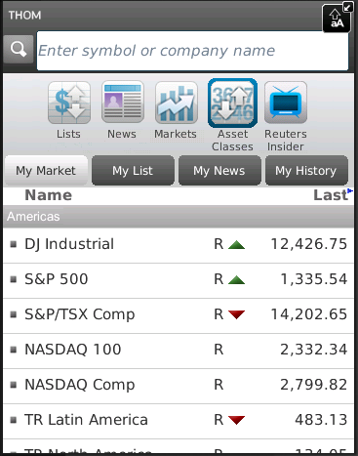

Financial content of the Home screen

Search bar

Main horizontal menu with icons

Customer of the project (named Brian) wants to implement a new feature for this project. Brian was working with business analyst John on requirements for this feature.

So, your task is:

1. Review the requirements for the new feature provided by John.
2. In case of any questions you need to write email to John with request to clarify your questions.
3. Provide estimations for test activities for this feature by email to your test lead Victor.
4. Write test cases for the feature for smoke test.
5. Review provided screens with the implemented feature.
6. Find and submit bugs in case of any.
7. (*optional task) Send test results and your decisions about quality of the feature to Victor.

**Below you will find requirements for the feature and templates for emails, test cases, bug reports and so on, please fill in only those templates that you think reasonable in scope of this feature. Also you can write any additional information that you want.**

## Requirements for the new feature

**User story #045**

**Summary**: As a user I want to access my Profile from the Home screen

**Priority**: Major

**Description**:

* Profile menu icon exists in the Home screen.
* Profile menu icon is positioned on the list of menu icons in the Home screen between Asset Classes and Reuters Insider icons.
* Profile view is displayed when Profile icon is selected.
* The Profile view must have header section (with name, company, location, thought of the day and photo).
* If photo is not available then default image is used.
* The rest of the person’s detail fields can be scrolled, only lines where user has added information are shown.
* Text size must not be too small.

## The feature #045 is ready for testing:

So, developers have finished implementation the feature #045. You received notification that the build with feature #045 was released and ready for testing. The build was successfully installed. Victor asked you to test the feature. You open the application -> login -> and see the Home screen provided below:

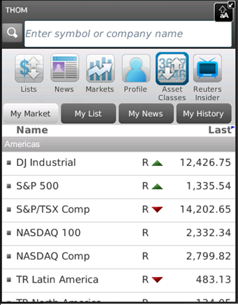

Upon clicking Profile icon in the main horizontal menu the next screen is opened:

